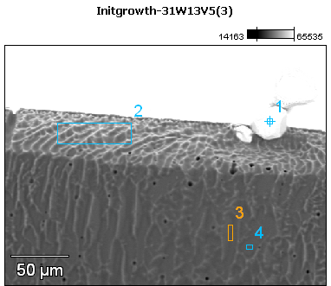

Image Name: Initgrowth-31W13V5(3)

Image Resolution: 512 by 384

Image Pixel Size: 0.55 µm

Acc. Voltage: 13.0 kV

Magnification: 450

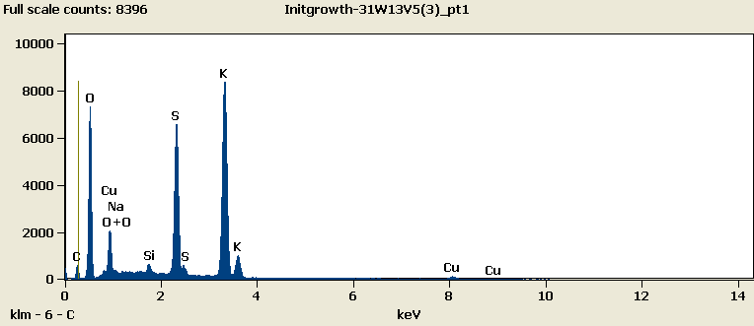

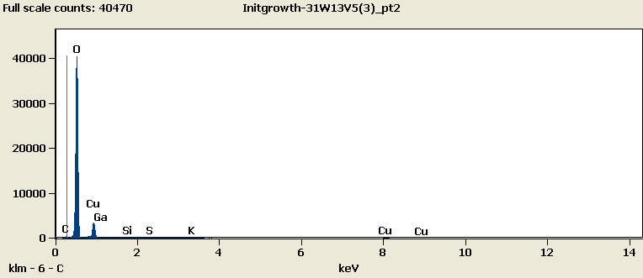

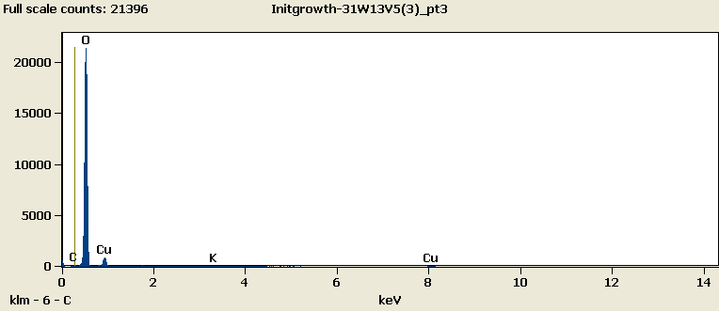

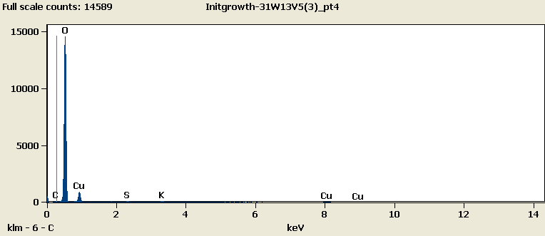

Weight %

|  |  |  |  |  |  |  |  |  |
| --- | --- | --- | --- | --- | --- | --- | --- | --- |
|  | ***C-K*** | ***O-K*** | ***Na-K*** | ***Si-K*** | ***S-K*** | ***K-K*** | ***Cu-L*** | ***Ga-L*** |
| ***Initgrowth-31W13V5(3)_pt1*** | 4.45 | 34.28 | 0.52 | 0.49 | 16.23 | 33.94 | 10.07 |  |
| ***Initgrowth-31W13V5(3)_pt2*** | 1.51 | 71.29 |  | 0.10 | 0.26 | 0.33 | 24.91 | 1.60 |
| ***Initgrowth-31W13V5(3)_pt3*** | 0.35 | 82.20 |  |  |  | 0.48 | 16.96 |  |
| ***Initgrowth-31W13V5(3)_pt4*** | 0.12 | 78.03 |  |  | 0.33 | 0.75 | 20.77 |  |

Weight % Error (+/- 1 Sigma)

|  |  |  |  |  |  |  |  |  |
| --- | --- | --- | --- | --- | --- | --- | --- | --- |
|  | ***C-K*** | ***O-K*** | ***Na-K*** | ***Si-K*** | ***S-K*** | ***K-K*** | ***Cu-L*** | ***Ga-L*** |
| ***Initgrowth-31W13V5(3)_pt1*** | ±0.15 | ±0.21 | ±0.05 | ±0.04 | ±0.10 | ±0.18 | ±0.16 |  |
| ***Initgrowth-31W13V5(3)_pt2*** | ±0.09 | ±0.23 |  | ±0.02 | ±0.04 | ±0.03 | ±0.25 | ±0.23 |
| ***Initgrowth-31W13V5(3)_pt3*** | ±0.11 | ±0.29 |  |  |  | ±0.05 | ±0.27 |  |
| ***Initgrowth-31W13V5(3)_pt4*** | ±0.12 | ±0.30 |  |  | ±0.05 | ±0.14 | ±0.32 |  |

# Cations

|  |  |  |  |  |  |  |  |  |
| --- | --- | --- | --- | --- | --- | --- | --- | --- |
|  | ***C-K*** | ***O-K*** | ***Na-K*** | ***Si-K*** | ***S-K*** | ***K-K*** | ***Cu-L*** | ***Ga-L*** |
| ***Initgrowth-31W13V5(3)_pt1*** | 0.00 | 0.00 | 0.00 | 0.00 | 0.00 | 0.00 | 0.00 |  |
| ***Initgrowth-31W13V5(3)_pt2*** | 0.00 | 0.00 |  | 0.00 | 0.00 | 0.00 | 0.00 | 0.00 |
| ***Initgrowth-31W13V5(3)_pt3*** | 0.00 | 0.00 |  |  |  | 0.00 | 0.00 |  |
| ***Initgrowth-31W13V5(3)_pt4*** | 0.00 | 0.00 |  |  | 0.00 | 0.00 | 0.00 |  |